

**JOMO KENYATTA UNIVERSITY OF AGRICULTURE AND TECHNOLOGY**

**KAREN CAMPUS**

**Topic**: **Laptop Security System**

Presented by: **John Eshiwani**

Reg no: SCT121/C002-0343/2016

Diploma Information Technology

**Supervisor**: **Miss**. **Jedidah Mwaura**

Submitted to the faculty of Information Technology in partial fulfillment of the requirements for the award of Diploma in Information Technology.

**MAY 2019**

**Declaration:**

I John Eshiwani declare that this is my project and has never been submitted to this or any other university for the award of a Diploma in Information Technology or any other award. All foreign materials have been cited in the references.

Student signature

Sign …………………………… Date………………………………….

Supervisor’s signature

Sign ………………………………. Date ………………………...

**Acknowledgment**

The completion of this undertaking could not have been possible without the participation and assistance of so many people whose names may not all be enumerated. Their contributions are sincerely appreciated and gratefully acknowledged.

If there is a driving force that kept me going through the entire period I was working on this project,

it was the support of my Supervisor, Miss. Jedidah Mwaura. It wasn’t easy, but you made it look like

easy for me. Thank you so much for giving me a patient hearing, believing in me and clearing my

doubts whenever they arose.

I would also want to extend my profound gratitude to the entire IT Department, all the lecturers I engaged throughout my course. You made it possible for this project and it won’t be prudent to forget about your efforts. Thank you.

I would like to express my deep appreciation and indebtedness to the following, Mr. Victor Muriithi and Mr. George Manoti for their endless support, kind and understanding spirit during the creation of the project. To all the relative’s friends and others who in one way or another shared their support, either morally, financially and physically. Thank you.

Lastly, to the Great Almighty God, the author of knowledge and wisdom for His countless love.

**Abstract**

The system offers a dependable security measure when it come to laptops, data will never be lost. When it comes to systems-related problems, the supporting team is always alert so no need to worry. It also offers good and reliable backup plans and also serves as a notice board for the institution through the memo section in the homepage.

# **CHAPTER 1: Project Proposal**

# 1.0 Introduction

In this chapter, the researcher will cover introduction of the system and its related functionality.

Security system is a group of integrated electronic devices working together with a control panel to provide protection against thieves and other potential intruders (Simon 1999). Homes and machines without security system are 2.7 times more likely to be targeted by a burglar (Edward 2009).

# 1.1 Background

Most organizations nowadays lack laptop security system (Chart 2001). They rely on individuals to provide laptop security. This practice is risky, particularly when there is a large working panel and everyone is busy and multi-tasking. Therefore one may forget his or her laptop at someplace and another evil individual may decide to steal it. The result will be catastrophic, in that the victim will loose his/her own data and money which result in slow service providence leading to loss of profit which is never the motive of starting a business.

# 1.2 Problem Statement

On December 2008 the Ministry of Defense released on account of high rise of laptop theft (Edward 2009). Many questions arouse as the result of the research regarding citizens and their properties safety. The research went on further to narrate that the stealing of the laptops is not done at an open air spaces like on the road or a market place but rather where they are used most, that include in schools and working places.

# 1.3 Research Objectives

The researcher is aiming to build a web-based system which will prevent the stealing of laptops in various organizations. In which a security personnel will upload a staff or a student laptop data like serial number,laptop model etc which will be used for verification.

The study will also include construction of different tables where the respective party data will be uploaded from. The system will also offer a memo section where one will be reminded of any upcoming event in the organization.

# 1.4 Specific Objectives

In regard of the above problem statement, The researcher objectives of the proposed system are as follow:

1. To develop a system that will be platform independence ie can be used in both large and small screen devices.
2. To develop a system that will less costly both to the user and the developer.
3. To develop a system that will be secure in terms of hacks.
4. To develop a system using available resources and knowledge to as to ensure availability of spare parts in case of any irregularity or breakage.

# 1.5 Research Questions

1. How can a developer build a system that will appear the same in both large and small screens?
2. How will be the system development and maintenance be less costly?
3. How will be a less costly system be secure?
4. Will the development of a system using available resources block room for improvement?

# 1.7 Justification

This study will eventually solve the problem of laptop theft in organizations, by developing a system which will make sure that one leaves office or school with his or her own laptop.

The system will also serve as a reminder to students and staff in any memo.

# 1.8 Scope

The scope will cover JKUAT Karen, Co-operative Bank Gataka branch and Tangaza College.

The system will only be dealing with laptops owned by the relevant parties. Computer like devices like tablet will not be included in the system. Likewise mobile phones will not also be included in the system.

The system will depend and function entirely on the information entered by the relevant users.

# 1.9 Limitations and Assumptions

Due to economic inflation in various aspects of life, for example bus fare, printing, internet fee and photocopying costs, the researcher will narrow down the system to cover only laptops because if the researcher decides to cover all electronic devices will be massively costly and much time consuming.

The study assumes that:

The system user is

1. Computer literate.
2. Understand English.
3. Can type atleats 60 words in a minute.
4. Have some knowledge in SQL.(system admin)

# 1.10 Conclusion

After understanding how companies lack security systems. How thieves make organizations loose profits and students looses their laptops alongside their data which may include the final year projects, It is evident that a computer based system will be a great relief to the relevant concerned parties.

People will no longer worry about their laptops in offices and school, Companies will no longer loose important data and customers will no longer be lacking any service.

With this system in place, many questions will have answers, costs will be reduced and profits will be maximized.

# **CHAPTER 2: Literature Review**

# 2.0 Introduction

In this literature review, the researcher will discuss in details two security systems based particularly on laptop safety, one used globally the other locally. What they are, what led to their development, how they work, their weaknesses and there will be also few pictures for better understanding and explanations.

# 2.1 Current System

Security system are special designed and integrated components that work together to detect any intrusion and unauthorized entry into an area. They are used in residential, commercial, industrial and military properties against theft or damage.

In this literature review, the researcher will discuss in details two security systems based particularly on laptop safety, one used globally the other locally. What they are, what led to their development, how they work, their weaknesses and I will also place a few pictures for better understanding and explanations.

# 2.2 Global security system.

University of Al Mouradi in Tunisia, one of the top universities in North Africa region use a security system to monitor and to control inlet and outlet of machines.

Reason for system development

The institution decided to introduce the system due to much complains from the students, heads of departments and staff about machines and essential parts theft.

How it works

The concerned parties for example staff, are supposed to give details of their machines once and do so in case of any new purchase, the information include the serial number for machines. The given data is then stored and backed up as specimen. At the exit point, there are computers with scanners connected with cables to the server. The work of these computers is to reflect the specimen data at the exit point for the security officer in charge to compare the data given with what is on the machine and decide whether the machine is being handled by the rightful owner. Short term visitors are also supposed to give their machines details at the entry point so as to make sure they are leaving with what is theirs.

This system is also fitted with alarms, in that; it does not only resist theft but also inform the people and the required authorities in case of an emergency like fire. It is fitted with smoke and water sensors to prevent fires and flooding in case some taps are left open by a user or a smoke which may cause huge flame.

The weaknesses of this system are:

1. Client computers are connected to the server via cables; this may cause malfunction in case of wire damage by rodents or any other risk.
2. The system also requires monthly fee for alarm monitoring this results to expense increase in the organization.
3. The system is extremely expensive to buy and to maintain. It requires several updating of software and in some case hardware.

Figures one and two below explain more of the system.

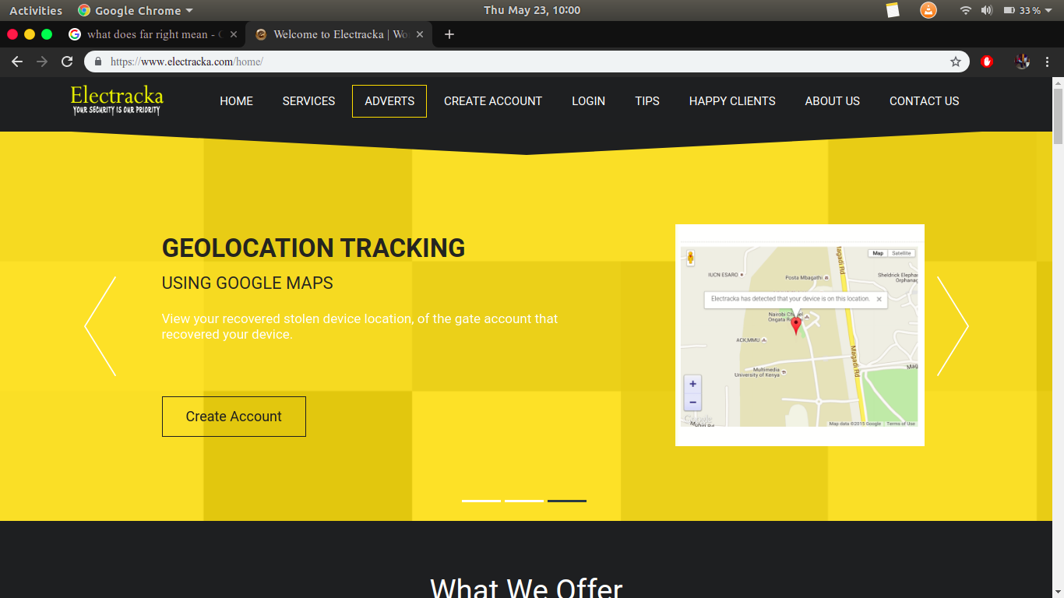

Figure 1 Almouradi system sign-up page

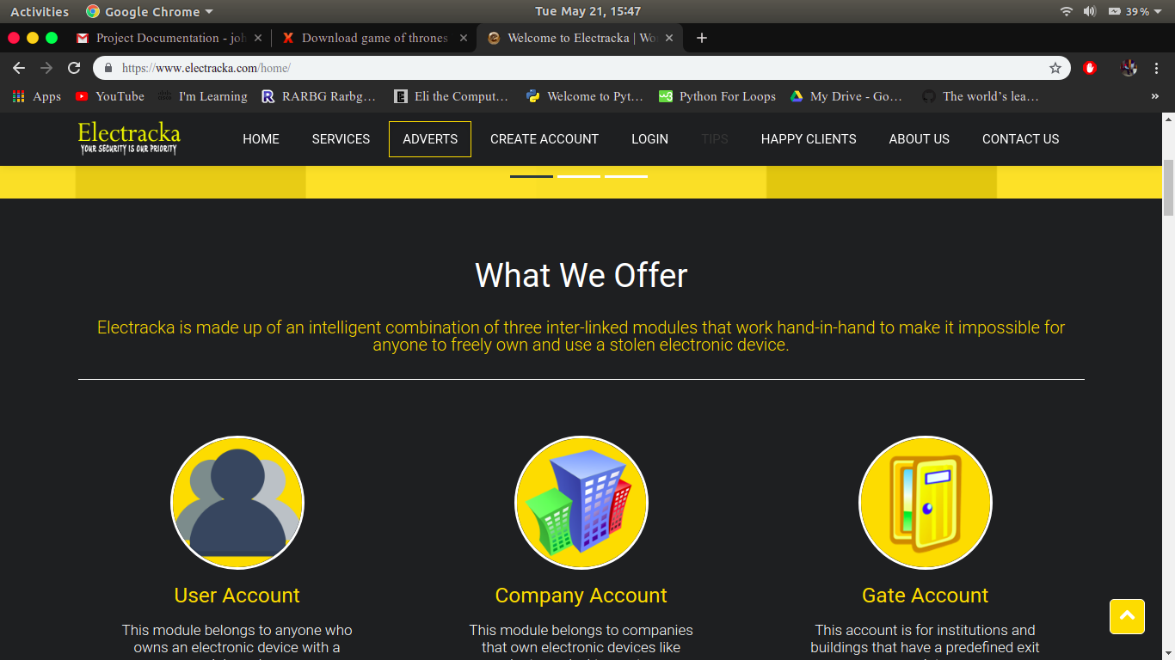Figure 2 smoke detectorin a room

# 2.3 Local system

Multi-media University of Kenya (MMU) an institution placed at the outskirts of the capital city Nairobi, formally a constitute of Kenyatta University, uses a security system which differs somehow with that of Al Mouradi University.

Reason for development

The system was introduced due to increased level of laptop and other essential belongings theft in school.

How it works

The system is composed of cables connecting the server and several clients computers placed at the entrance. The system only deals with laptops and CCTV cameras; Laptop holders are supposed to give their machine details, the data is then stored as specimen data which also reflects at the exit point clients used by security officers to confirm possession. After students have completed regular security checkup, those found in possession of laptops undergo another checkup to ensure they are entering with their laptops and also another checkup is done during their departure. Visitors are supposed to give their details when they arrive and the checkup is done when they are leaving. The CCTV cameras are used for general security in the campus.

The weaknesses of this system are:

1. The process may be slow if the number of students leaving the campus is high.
2. The system doesn’t offer other security measures like fires and floods.
3. The connection of cables may cause malfunction in case of wire damage.

Figures below explain more of the system.



Figure 3 Electraka front page

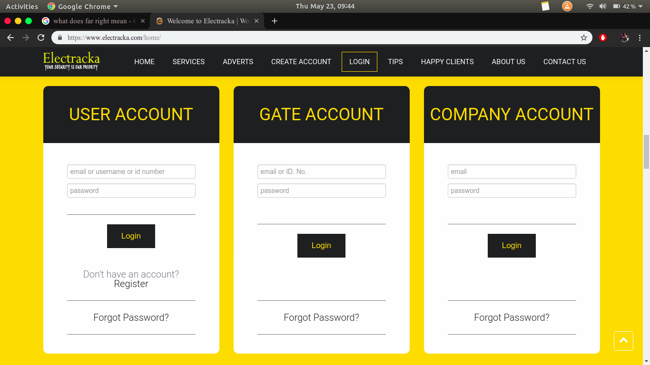Figure two MMU sign up page

# 2.4 Proposed System

The proposed system will capitalize on the strengths of the existing systems and also try to solve the challenges that are still not addressed by the systems in place.

The proposed system will conduct its checkup during departure time to avoid long queue in the arrivals because most people depart in small and manageable numbers and also in different time. Visitors will have to give their details during arrival at the entrance to ensure they are leaving with their rightful laptops.

# 2.5 Conclusion

Security systems can boost economy by ensuring people and their possessions safety (Chart 2001). The proposed system will combine some of the capabilities of the available systems and come up with one that is simple and come up with a whole rounded system that will not only solve the current problems, but also look at the future will-optimism.

The proposed system will include some features like:

1. Proper backup- Apart from electronic backup, my system will provide a platform which one can backup data manually in books. These data will be used in case there is power loss and backup generator failure.
2. Room for advancement- The system will welcome any necessary update technology for better service providence. The advancement can be for example using of special scanners or movable bar code readers at the exit point to read the serial number on the machine and then it automatically reflect in the monitor all the particular required information like the owner, type and color. This will make security checkup easy and fast.

# Chapter 3: Methodology

# 3.0 Introduction

This chapter presents methods to be used in the study, it also entails description of data collection methods, sources of data, research methodology and many more related topics.

# 3.1 System Development

Agile software development is an approach to software development under which requirements and solutions evolve through the collaborative effort of self-organizing and cross-functional teams and their customer/end user.

[Wikipedia](https://en.wikipedia.org/wiki/Agile_software_development)

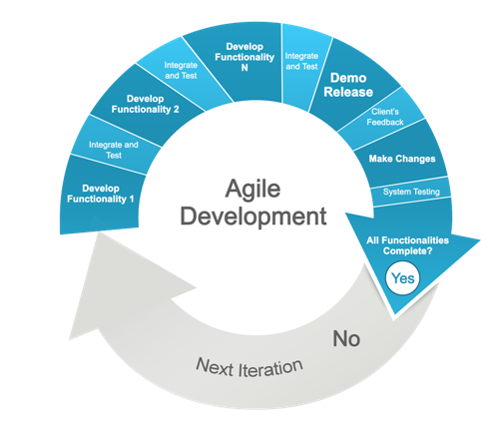

Both the developer and the system owner heavily interact during the development process to ensure that the made system fully satisfies its owner.Whenever the owner comes up with a new idea, it is integrated in the system until he/she is satisfied.

# 3.2 System Design Model

System design is the process of defining the architecture, modules, interfaces, and data for a system to satisfy specified requirements.

This describes how different users will be interacting with the system. The steps involved are:

1. Sign up
2. Login
3. Validation
4. Loading of the home page

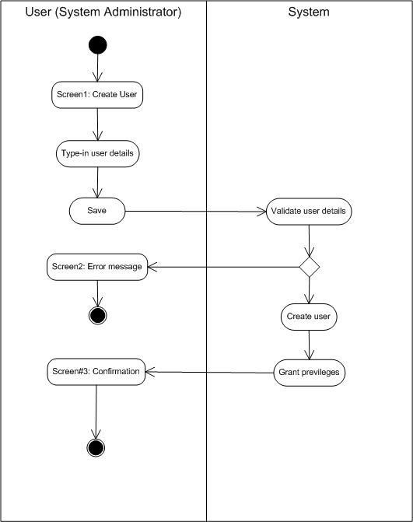

# 3.3 Research Methodology

The researcher decided on a number of methods to collect the necessary information needed to make informed decisions about the system development. The methods used were; interviews,observation and social media platforms. These will help the researcher to come up with a solid resolution.

## 3.3.1 Interviews

This is the technique where the researcher books a face to face appointment with the individuals in the research area to know how they interact with the systems in place.

This method was very helpful for this research since it gave the developer the opportunity to physically meet the system’s potential users and could easily read from their responses and also from their expressions the agony that they are passing through in their day to day operations due to the absence of a reliable system.

## 3.3.2 Observation

For the researcher to be certain about the responses given by the interviewed audience, the researcher resolved to use the observation method to ascertain the views of the interviewees and also cover some niches which were not covered by the interview.

## 3.3.3 Social media

The researcher also had time to discuss this problem in different social media platforms such as Whats App groups and Facebook groups.

The group members overwhelmingly agreed to the fact that there was a great challenge in securing laptops. Some even suggested if there could be system to solve this menace since most people are currently computer literate and good programmers are all over the country.

# 3.4 System Development Tools

The system database will be developed using MySQL. The abbreviation SQL stands for Structured Query Language which is an open-source relational database management system.

## 3.4.1 Database

MySQL is a central component of the LAMP open-source web application software stack (and other "AMP" stacks). LAMP is an acronym for "Linux, Apache, MySQL, Perl/PHP/Python". Applications that use the MySQL database include: TYPO3, MODx, Joomla, WordPress, phpBB, MyBB, and Drupal. MySQL is also used in many high-profile, large-scale websites. (<https://Wikipedia/wiki/MySQL>)

## 3.4.2 User Interface (UI)

Because the system is web-based, the User interface will be developed using HTML(Hypertext Markup Language) which is the standard language for making web pages and web applications on the client side. It will also use PHP (Hypertext Processor) which is used as the server-side scripting language. The HTML codes will be embedded in PHP.

## 3.4.3 Hosting

The system will require testing before implementation even as the developer continues with the development process. This cannot be achieved without a server that is based in the computer. Because of these reasons, the researcher proposes the use of xampp as the local host server. XAMPP here stands for Cross-Platform (X), Apache (A), MariaDB (M), PHP (P) and Perl (P). It is free and open source cross-platform web server solution stack package developed by Apache Friends, consisting mainly of the Apache HTTP Server, MariaDBdatabase, and interpreters for scripts written in the PHP and Perl programming languages.(<https://en.wikipedia.org/wiki/XAMPP>)

## 

## **3.4.4 Text editor**

The text editor to be used is vs code. It provides a good platform were HTML,CSS and PHP codes can be written and also it have intellisense and code snippets for easier and faster coding.

## 3.4.5 Photo Editing Tools

Inkscape is a good photo editing tool. It is supported by the Ink corporation which send updates to ensure maximum efficiency in photo editing.

# 3.5 Users of the system

There will be only two users of the system they include:

1.System Administrator

The system admin will be allowed by the system to perform the following:

* Sign in to the database.
* Add new data into the system
* View and edit existing data
* Delete data
* Upload photos for the carousel
* Upload memos
* Monitor the whole system

2.Security Personnel

The security personnel will have the following privileges:

* Sign in the front-end
* View existing users
* Remind relevant parties of a new memo

# 3.6 Conclusion

The data sources, their collection methods, their analization methods and tools for implementing and testing have been covered in the entire document content.

# CHAPTER 4: SYSTEM ANALYSIS AND DESIGN

# 4.0 Introduction

This chapter covers systems analysis and design, it includes diagrams and explanations which supports the covered topics.

# 4.1 System Narrative

This system works and operate on a simplified network environment.

The system administrator is responsible for maintaining the server, he/she is also responsible for supporting and responding to service outages and other problems. He/she also have limitless access to the system and can make any changes on the database without any restrictions.

# 4.2 Use Case Diagram

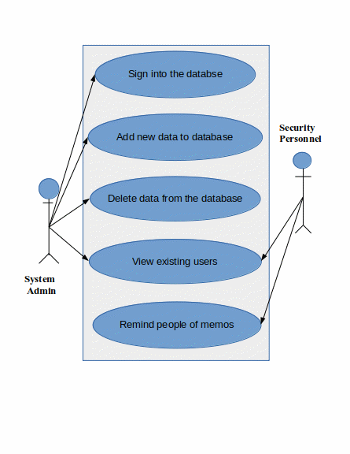

# 4.3 Activity Diagram

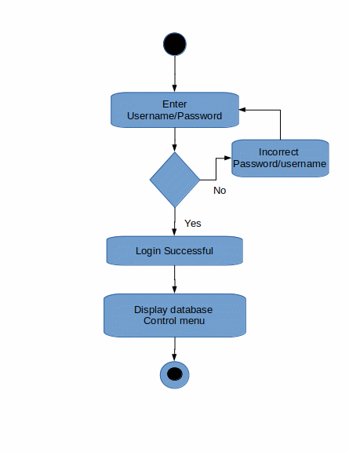

# 4.4 Flowchart

# 

# 4.5 Class Diagram

# 4.6 Entity Relational Diagram (ERD)

# 4.7 Database Schema

# 4.8 System Requirements

The proposed system requires simple hardware and software components which are very easy to find and to maintain.

## 4.8.1 Hardware Requirements

|  |  |
| --- | --- |
| **Hardware** | **Specificity** |
| 1. Hard disk | 500 GB |
| 1. CPU | Intel Celeron |
| 1. RAM | 2GB |
| 1. Mouse | Hp Invent |

## 4.8.2 Software Requirements

|  |  |
| --- | --- |
| **Software** | **Specificity** |
| 1. Ubuntu 18.04.2 LTS | Free and Open source software |
| 1. LibreOffice Writer | Free software |
| 1. Inkscape | Free software |
| 1. XAMPP | Free software |

# 4.9 Conclusion

The above diagrams explains the relevant ideas of the system.

# CHAPTER 5 : SYSTEM IMPLEMENTATION AND TESTING

# 5.0 Introduction

In this chapter, the researcher will cover some aspects which includes security of the collected data, error handling just to mention a few.

# 5.1 System Modules

## 5.1.1 Web survey module

Used to view other security web sites to affirm their productivity.

## 5.1.2 Interviewing Module

The module was used to collect first hand information from the interviewee.

# 5.2 Modules Implementation

## 5.2.1 Web survey module

The module was used to offer and full service hosting, this enabled the clients to produce reports on the survey regardless of whether the data was from the web.

## 5.2.2 Interviewing module

The surveyor conducted interviews on the respondents appropriate time this not only made sure that the flow of things got interrupted but also gave accurate responses.

# 5.3 Information Security

The information collected from any of the surveys will be stored in google cloud storage by providing a unified offering across the availability spectrum, from live data tapped by today’s most demanding applications. The database will also be used to encrypt any valuable information from any of the conducted surveys.

# 5.4 Testing and Error Handling

The implementation of the system once rolled out is going to cover colleges and organizations countrywide, testing of the system is done during the implementation process to ascertain that the system would achieve the basic design platform it is intended to perform any errors which may arise during implementation will be handled accordingly.

# 5.5 Conclusion

As a process for integrating human considerations into the system engineering process, the developer has built on the strengths of existing systems engineering process model (prototype) to synthesis an incremental commitment model that help situate activities within a system’s life.

# CHAPTER 6: CONCLUSION AND RECOMMENDATION

## 6.0 Introduction

In this chapter, we report our broad conclusions related to each of the themes we introduced at the start of the documentation. These conclusions reflects detailed consideration.

# 6.1 Achievements

1. Development of a simple yet effective system.
2. Utilized local resources so there will be always availability of spare parts.
3. Development of a cheap yet very secure system.

# 6.2 Difficulties

1. High transport costs sometimes.
2. Low quality printing.
3. Learning of new technologies and technique like bootstrap and pictures editing.

# 6.3 Conclusion

In this rapid development of the world as a whole, both developed and developing nations, modern computer technologies are taking over. Long gone are the days when you could leave your car, home, office or personal equipments unattended. Bulgars are everywhere, they can be anyone, well dressed or poorly dressed and they are out there on a mission, to steal!!

But as the sage goes, ‘In every desert of clalamities, there is an oasis of comfort’. Our comfort nowadays are the security systems. They are automated hence they are on 24/7. No human being is capable of that, they produce reliable data and they never wrong or lie. Garbage In Garbage Out is the principle used during their manufacture hence if you see an error somewhere, check your input it is your fault.

With all that said, I conclude by saying precaution is better than cure. Therefore, security systems should be appreciated and welcomed.

# 6.4 Recommendation and Future Study

The main objective of this project is to design an automated security system that can analyze records, store them and retrieve them when need.

However, the following challenges were encountered during the implementation: It was very difficult and tiresome to all those fields of data. It was also expensive for an organization to hire two or more different security firms, in that one firms deals with only with laptop security and the other deals with something else like alarm system.

Any further work on the project could incorporate the following suggestions for improvement:

1. Scanners can be incorporated in the system for data collection and retrieval.
2. The system can be merged with other systems like the surveillance and alarming systems.

# References

1. Wikipedia.
2. [Https://www.googlesearch.com](https://www.googlesearch.com/)
3. Simon, Hakim. 1999. *Securing Home and Business*. West publishing Company.
4. Edward, Snow den and the US Surveillance State 2009.*No Place to Hide.* Zondervan Publishing House.
5. Chart, West fall 2001*.Internet links to everything from commerce to courting*. World University Library.

# Appendices

## Appendices A: Code Snippet

<div class="container">

<nav class="navbar navbar-dark fixed-top navbar-expand-md bg-dark">

<button type="button" class="nav-toggler" data-toggle="collapse" data-target="#myNav"><span class="navbar-toggler-icon"></span></button>

<div id="myNav" class="collapse navbar-collapse">

<div class="h3 text-primary ml-5">Eshiwani Security Systems(ESS)</div>

<ul class="navbar-nav ml-auto">

<li class="nav-item"><a href="index.php" class="nav-link">Home</a></li>

<li class="nav-item"><a href="Registration.php" class="nav-link">Registration</a></li>

<li class="nav-item"><a href="https://www.google.com" class="nav-link">Google</a></li>

<li class="nav-item"><a href="https://www.youtube.com" class="nav-link">YouTube</a></li>

</ul>

</div>

</nav>

</div>

<!--this is the carousel-->

<div id="john" class="carousel slide" data-ride="carousel">

<!--slideshow-->

<div class="carousel-inner fluid sizing">

<div class="carousel-item active">

<img class="d-block w-100" src="img/team.jpg" alt="First slide">

</div>

<div class="carousel-item ">

<img class="d-block w-100" src="img/startup.jpg" alt="Second slide">

<!--<div class="carousel-caption"><span class="h4 text-white">Forgot your laptop at work? No worries as

long as you have ESS systems around you.</span></div>-->

</div>

<div class="carousel-item">

<img class="d-block w-100" src="img/workplace.jpg" alt="Third slide">

</div>

</div>

</div><br />

## Appendices B: Sample interview questions

To the students;

1. What is your name?
2. Which year are you currently?
3. What is your course of study?
4. Do you posses a laptop?
5. Have you lost one in school?
6. Do you feel your laptop is secure in school?
7. Do you think a laptop security system will enhance your machine security?

## Appendices C: Project Deliverables

|  |  |  |
| --- | --- | --- |
| **Activity** | **Start period** | **End period** |
| Analysis | 3/1/2019 | 28/2/2019 |
| System design | 2/3/2019 | 31/3/2019 |
| Implementation & Testing | 1/4/2019 | 29/4/2019 |
| Maintenance | 5/5/2019 |  |

## Appendices D:Budget

|  |  |  |
| --- | --- | --- |
| **Item** | **Description** | **Cost (Kshs.)** |
| * Hardware | Lenovo laptop B51 type with 2GB RAM and 500GB storage space. | 32 000 |
| * Transport cost | From Ongata Rongai to Nairobi and other places. | 3 000 |
| * Internet fee | Data bundles | 5 000 |
| * Miscellaneous | For photocopying,binding and printing of documents. | 1000 |
| **Grand Total** |  | **41 000** |

## Appendices E: Gnatt Chart

|  |  |  |  |  |  |
| --- | --- | --- | --- | --- | --- |
| Analysis |  |  |  |  |  |
| Design |  |  |  |  |  |
| Implementation |  |  |  |  |  |
| Testing |  |  |  |  |  |
|  | January | February | March | April | May |